2A2B HUMAN BIOLOGY DIGESTIVE & EXCRETORY SYSTEM TEST

Name:_____________________________ /75

**Part one – multiple choice**

1. Digestion begins in the mouth. Which of the following statements is INCORRECT?

a) The tongue aids in the digestion of food.

b) The saliva changes some of the starches in the food to sugar.

c) The tongue keeps the food in place in the mouth while the food is being chewed.

d) Saliva can react more easily with the food when chewed.

2. Our pharynx divides into two separate tubes: the trachea and the oesophagus. What prevents food from entering the trachea?

a) The uvula

b) The tongue

c) The trachea

d) The epiglottis

3. Where does the partly-digested food (in liquid form) go after it leaves the stomach?

a) The liver

b) The appendix

c) The duodenum

d) The small intestine

4. Digestion takes place in a long tube-like canal called the alimentary canal, or the digestive tract. Food travels through these organs in the following order:

a) Mouth, oesophagus, stomach, small intestine, large intestine and rectum

b) Mouth, oesophagus, stomach, large intestine, small intestine and rectum

c) Mouth, stomach, oesophagus, small intestine, large intestine and rectum

d) Mouth, stomach, oesophagus, small intestine, large intestine and rectum.

5. Another term for swallowing of food is:

a) Digestion

b) Ingestion

c) Degustation

d) Peristalsis

6. The removal of metabolic waste products from the body of a mammal is known as

1. Egestion
2. Excretion
3. Secretion
4. Defecation

7. The composition of urea in urine is

a) 0.5%

b) 1.5%

c) 2.0%

d) 4%

8. Which of the following is **not** a function of the kidneys?

a) Regulating the composition of the body fluid

b) Regulating the water balance of the body

c) Regulating the body temperature

d) Removing the excess salts

9. Normally, concentrations of metabolically **important** substances are:

a) High in the glomerular filtrate and low in urine

b) Low in the glomerular filtrate but high in urine

c) High in both the glomerular filtrate and urine

d) Low in both the glomerular filtrate and urine

10. Homeostasis is the mechanism by which the body maintains:

a) A dynamic physiological state within an unlimited range.

b) A relatively stable internal environment, within limits.

c) A static physiological state with no deviation from preset points.

d) The lowest possible usage of energy.

11. What substance is produced by the liver?:

a) Amylase

b) Bile

c) Gastric Juice

d) Gallic Juice

**Part Two – short answer**

1a. What is the function of bile?

___________________________________________________________________________________

(1 mark)

1b. Where is this substance stored? ________________________ (1 mark)

2. Complete the table below.

|  |  |  |
| --- | --- | --- |
| Structure | Where they are found | Function |
| Circular and longitudinal muscle layers |  |  |
| Villi |  |  |

(4 marks)

3. Explain what peristalsis is and where it occurs.

___________________________________________________________________________________

___________________________________________________________________________________

___________________________________________________________________________________

___________________________________________________________________________________

(2 marks)

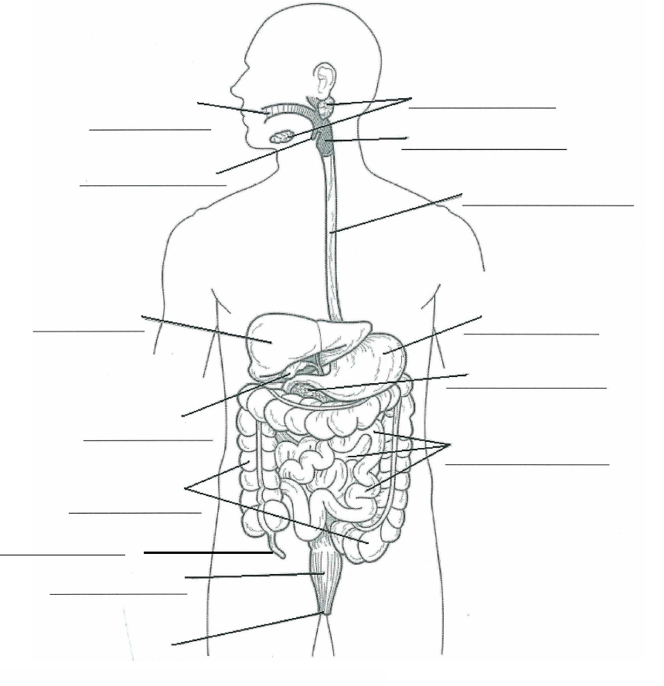4. Label the diagram below.

(6 marks)

6. Fill in the table below.

|  |  |  |  |  |
| --- | --- | --- | --- | --- |
| Name of enzyme | Where it is made | Where it is found (used) | What it acts on (substrate) | Product |
| Salivary amylase |  |  |  |  |
| Pancreatic lipase |  |  |  |  |
| Pancreatic protease (trypsin) |  |  |  |  |

(12 marks)

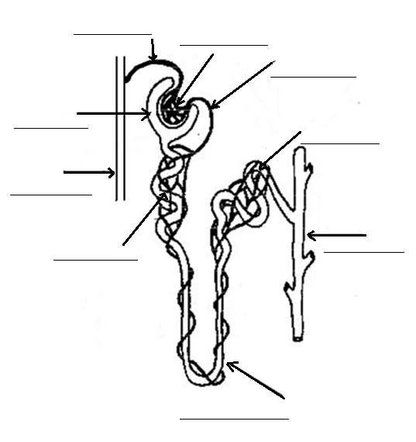1)Label the following diagram of a nephron. (4 marks)

3)Jason decided to go for a run around Lake Monger. He forgot to take his water bottle with him and began feeling a little light headed and had a headache.

Complete the feedback loop to explain how Jason’s body is dealing with dehydration. (6 marks)

**Effector**

**Stimulus**

**Receptor**

**Modulator**

**Feedback**

**Response**

4) Complete the table below. **Not all the boxes should be filled.** (8 marks)

|  |  |  |  |
| --- | --- | --- | --- |
| Part of nephron | Substances being  reabsorbed | Substances being  filtered | Substances being  secreted |
| Loop of Henle |  |  |  |
| Bowman’s capsule |  | Glucose  Phosphate ions |  |
| Distal convoluted  tubule |  |  |  |

5) Why can some substances pass through the membrane of the glomerulus, but others cannot? Give 2 examples of substances that can pass through, and 2 substances that cannot.

(5 marks)

___________________________________________________________________________________

___________________________________________________________________________________

___________________________________________________________________________________

___________________________________________________________________________________

___________________________________________________________________________________

___________________________________________________________________________________

___________________________________________________________________________________

6a) Explain how blood in the glomerulus kept under a high pressure. (3 marks)

___________________________________________________________________________________

___________________________________________________________________________________

___________________________________________________________________________________

___________________________________________________________________________________

___________________________________________________________________________________

___________________________________________________________________________________

___________________________________________________________________________________

b) Why is it so important that this blood be kept under a high pressure? (2 marks)

___________________________________________________________________________________

___________________________________________________________________________________

___________________________________________________________________________________

___________________________________________________________________________________

___________________________________________________________________________________

___________________________________________________________________________________

___________________________________________________________________________________

___________________________________________________________________________________

___________________________________________________________________________________

Part three – extended answer

Describe the process of protein deamination in the human body. You must include step by step details.

(10 marks)

__________________________________________________________________________________________

__________________________________________________________________________________________

__________________________________________________________________________________________

__________________________________________________________________________________________

__________________________________________________________________________________________

__________________________________________________________________________________________

__________________________________________________________________________________________

__________________________________________________________________________________________

__________________________________________________________________________________________

__________________________________________________________________________________________

__________________________________________________________________________________________

__________________________________________________________________________________________

__________________________________________________________________________________________

__________________________________________________________________________________________

__________________________________________________________________________________________

__________________________________________________________________________________________

__________________________________________________________________________________________

__________________________________________________________________________________________

__________________________________________________________________________________________

__________________________________________________________________________________________

__________________________________________________________________________________________

__________________________________________________________________________________________

__________________________________________________________________________________________

__________________________________________________________________________________________

__________________________________________________________________________________________

__________________________________________________________________________________________

__________________________________________________________________________________________

__________________________________________________________________________________________

__________________________________________________________________________________________

__________________________________________________________________________________________

__________________________________________________________________________________________

__________________________________________________________________________________________

__________________________________________________________________________________________

__________________________________________________________________________________________

__________________________________________________________________________________________

__________________________________________________________________________________________

__________________________________________________________________________________________

__________________________________________________________________________________________

__________________________________________________________________________________________

__________________________________________________________________________________________

__________________________________________________________________________________________

__________________________________________________________________________________________

__________________________________________________________________________________________

__________________________________________________________________________________________

__________________________________________________________________________________________

__________________________________________________________________________________________

__________________________________________________________________________________________

__________________________________________________________________________________________

__________________________________________________________________________________________

__________________________________________________________________________________________

__________________________________________________________________________________________

__________________________________________________________________________________________

__________________________________________________________________________________________

__________________________________________________________________________________________

__________________________________________________________________________________________

__________________________________________________________________________________________

__________________________________________________________________________________________

__________________________________________________________________________________________

**Part one – multiple choice**

1. Digestion begins in the mouth. Which of the following statements is INCORRECT?

a) The tongue aids in the digestion of food.

b) The saliva changes some of the starches in the food to sugar.

c) The tongue keeps the food in place in the mouth while the food is being chewed.

d) Saliva can react more easily with the food when chewed.

2. Our pharynx divides into two separate tubes: the trachea and the oesophagus. What prevents food from entering the trachea?

a) The uvula.

b) The tongue.

c) The trachea.

d) The epiglottis.

3. Where does the partly-digested food (in liquid form) go after it leaves the stomach?

a) The liver.

b) The appendix.

c) The duodenum.

d) The small intestine.

4. Digestion takes place in a long tube-like canal called the alimentary canal, or the digestive tract. Food travels through these organs in the following order:

a) Mouth, oesophagus, stomach, small intestine, large intestine and rectum.

b) Mouth, oesophagus, stomach, large intestine, small intestine and rectum.

c) Mouth, stomach, oesophagus, small intestine, large intestine and rectum.

d) Mouth, stomach, oesophagus, small intestine, large intestine and rectum.

5. Another term for swallowing of food is:

a) Digestion.

b) Ingestion.

c) Degustation.

d) Peristalsis.

6. The removal of metabolic waste products from the body of a mammal is known as

1. Egestion
2. Excretion
3. Secretion
4. Defecation

7. The composition of urea in urine is

a) 0.5%

b) 1.5%

c) 2.0%

d) 4%

8. Which of the following is **not** a function of the kidneys?

a) Regulating the composition of the body fluid

b) Regulating the water balance of the body

c) Regulating the body temperature

d) Removing the excess salts

9. Normally, concentrations of metabolically **important** substances are:

a) High in the glomerular filtrate and low in urine

b) Low in the glomerular filtrate but high in urine

c) High in both the glomerular filtrate and urine

d) Low in both the glomerular filtrate and urine

10. Homeostasis is the mechanism by which the body maintains:

a) A dynamic physiological state within an unlimited range.

b) A relatively stable internal environment, within limits.

c) A static physiological state with no deviation from preset points.

d) The lowest possible usage of energy.

11. What substance is produced by the liver?:

a) Amylase

b) Bile

c) Gastric Juice

d) Gallic Juice

**Part Two – short answer**

1a. What is the function of bile?

Emulsification of fats

(1 mark)

1b. Where is this substance stored? Gall bladder (1 mark)

2. Complete the table below.

|  |  |  |
| --- | --- | --- |
| Structure | Where they are found | Function |
| Circular and longitudinal muscle layers | Whole digestive tract – stomach, oesophagus, snall and large intestine, rectum | Food moves along via peristalsis  Churn in stomach |
| Villi | Small Intestine | Increases surface area for increased absorption |

(4 marks)

3. Explain what peristalsis is and where it occurs.

Progressive waves of contraction and relaxation of 1

aliamentary canal that pushes food along 1

(2 marks)

4. Label the diagram below.

Salivary Glands

Mouth

Epiglottis Pharynx (will accept larynx as unclear)

Oesophagus

Liver Stomach

Pancreas

Gall Bladder

Small Intestine

Large Intestine

Appendix

Rectum

Anus

Minus 1/2 mark for any one missing/incorrect

(6 marks)

6. Fill in the table below.

|  |  |  |  |  |
| --- | --- | --- | --- | --- |
| Name of enzyme | Where it is made | Where it is found (used) | What it acts on (substrate) | Product |
| Salivary amylase | Salivary glands | Mouth | Starch | disaccharides |
| Pancreatic lipase | Pancreas | Small intestine | Fats and lipids | Fatty Acids and glycerol |
| Pancreatic protease (trypsin) | Pancreas | Small Intestine | Protein | Peptide chains (polypeptide) |

(12 marks)

1)Label the following diagram of a nephron. (4 marks)

Afferent Arteriole Glomerulus

Efferent Arteriole

Glomerular Capsule

Distal Convoluted Tubule

Renal Artery

Proximal Convoluted Tubule Collecting Duct

Loop of Henle

3)Jason decided to go for a run around Lake Monger. He forgot to take his water bottle with him and began feeling a little light headed and had a headache.

Complete the feedback loop to explain how Jason’s body is dealing with dehydration. (6 marks)

1 mark each box

**Effector**

**Collecting duct and distal convoluted tubule open water channels**

**Stimulus**

**Dehydration or low water levels**

**Receptor**

**Osmoreceptors in hypothalamus of brain**

**Modulator**

**Hypothalamus causes pituitary gland to release ADH**

**Feedback**

**Body is Hydrated water is reabsorbed**

**Response**

**Increase in permeability of collecting duct and distal convoluted tubule**

4) Complete the table below. **Not all the boxes should be filled.** (8 marks)

|  |  |  |  |
| --- | --- | --- | --- |
| Part of nephron | Substances being  reabsorbed | Substances being  filtered | Substances being  Secreted |
| Loop of Henle | Water  Sodioum ions  Chloride ions |  |  |
| Bowman’s capsule |  | Glucose  Phosphate ions  Amino acids  Sodium ions  Chloride ions  urea |  |
| Distal convoluted  Tubule | Water  Sodium ions  Chloride ions |  | Potassium ions  Hydrogen ions  Creatinine  Drugs like penicillin |

- ½ mark for each one missing

5) Why can some substances pass through the membrane of the glomerulus, but others cannot? Give 2 examples of substances that can pass through, and 2 substances that cannot.

(5 marks)

1 some substances are too big to pass through the membrane

2 any two – H2O, glucose, amino acids,. Urea, sodium ions, chloride ions phosphate ions

2 any two – proteins, blood cells

6a) Explain how blood in the glomerulus kept under a high pressure. (3 marks)

The afferent arteriole has a wider diameter (larger lumen) 1

Than efferent 1

Larger volume of blood entering glomerulus but slower to leave 1

b) Why is it so important that this blood be kept under a high pressure? (2 marks)

Blood pushes against the wall of the capillaries 1

Forces small particles to move through capillary walls through membrane of Bowmans capsule 1

Part three – extended answer

Describe the process of protein deamination in the human body. You must include step by step details.

(10 marks)

1 proteins are made up of smaller molecules called amino acids

1 The body breaks down any amino acids it no longer needs by removing the amino group

1 process occurs in liver

1 wastes made through deamination have nitrogen in them, called nitrogenous wastes

1 Once the amino group is removed the rest is just carbon hydrogen and oxygen which is a carbohydrate and can be used to produce energy.

1 First one made is ammonia

1 ammonia is toxic

1 converts ammonia to urea

1 filtered out

1 in kidney

1 removed from body in urine & small amounts in sweat

(may skip one of the last 3 points and still get full marks)